INFERENCE FROM VIOLIN PLOT:

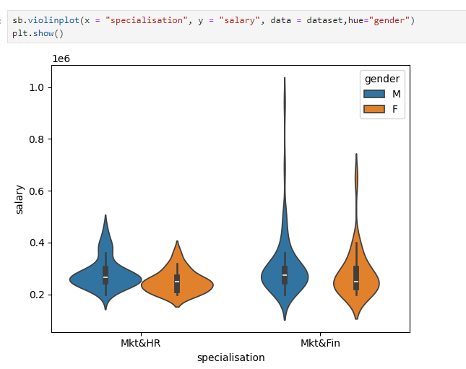

In this violin plot, we take the dependent variable – salary on the y-axis, and the independent variable, specialization on the x-axis.

Inference:

* Overall, Marketing and Finance specialization are getting better range of salary in comparison to Marketing and HR.
* Overall, Male is getting higher salary than Female.
* In Marketing and HR, Male are getting higher salary than Female.
* In Marketing and Finance, Male are getting higher salary than Female.